Name :SK.Kashifa

Registration no :192121135

Train Reservation system :

Class diagram :

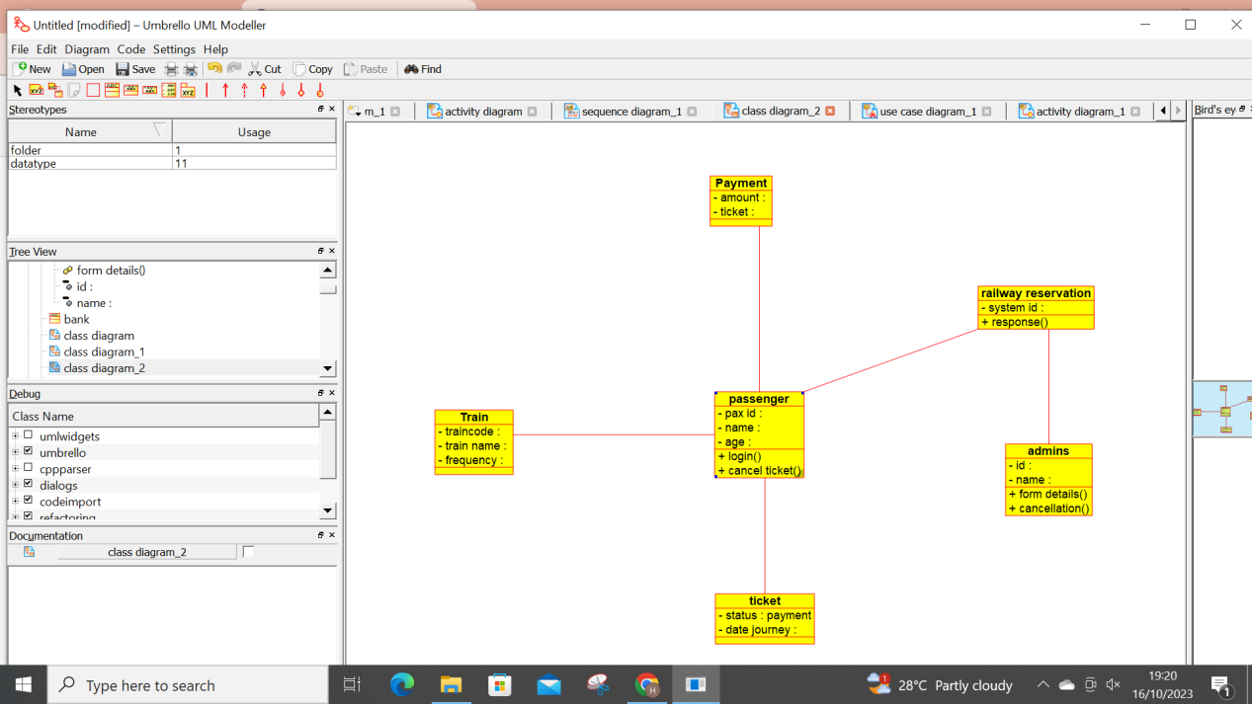

Activity diagram :

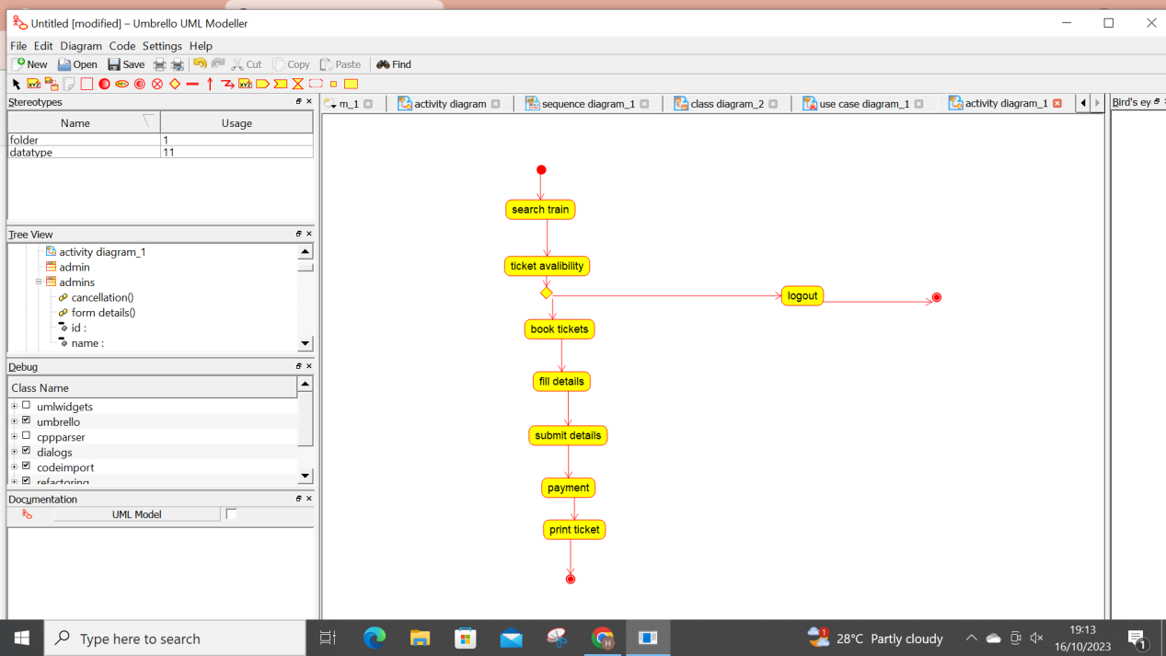

Usecase diagram :

